
Pir Meher Ali Shah
Arid Agriculture University, Rawalpindi
Office of the controller of Examinations
Mid Exam / FALL 2020
To be filled by Teacher
Course No.: CS-692 Course Title: Visual Programming
Total Marks: 12 Date of Exam: 9/12/2020

Q #1: Develop a “Window Form Application” in C# to fulfill the functionality of given below form. Functionality of each button is explained below.

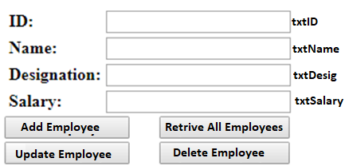

- Add Employee button will add new employee in DB with unique ID.
- Delete and Update Employee will be on the basis of employee ID.
- Retrieve All Employee button will retrieve all employees from DB table and populate into grid view control.
- Update Employee will update the existing employee; it Search employee on the basis of its ID.
Apply Exception handling in the code and before the Employee Record is Saved to Database,
Q #2: There is a windows form application with two ListBoxes on the form with the name LstLeft and LstRight. There are four buttons on the form as well (btnPopulate, btnRight, btnRightAll, btnClear). You need to find functionality as bellow:
i) When user click btnPopulate, write a code that will populate LstLeft with values One, Two, Three, Four, Five.
ii) When user click btnRight, if there is an item selected (otherwise give Message to user that no item is selected) in LstLeft, it would move from LstLeft to LstRight.
iii) When user click btnRightAll, if there are one or more items are selected in LstLeft, all will be moved from LstLeft to LstRight.
iv) When User click btnClear, write a code that will empty/clear both lists.
An example is given below,

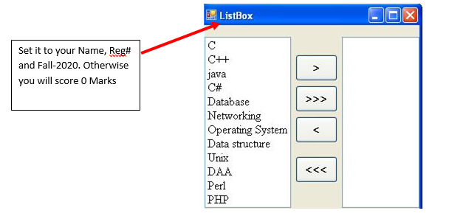
Important Notes : Set the Form Title (Text Property, in the Example it is set to ListBox) to your Name and Reg# and Fall-2020 (As an Example Saif Ur Rehman – 17-ARID-2020 – Fall-2020), otherwise you will score 0 marks in this Question.

Q # 3: Create a Menu Driven C-Sharp Application for UIIT Merit List for various programs.
- Create a Super Class, in which Program Name e.g. MCS, MIT, BSCS, BSIT and Shift (Morning or Evening) is stored.
- Create a Sub Class, inherit this class from Super Class. Further, in this class Form#, Applicant Names, Obtained and Total marks are stored (you have to use appropriate data structure for storing).
- Next, your application should compute the percentage against each Form No. Finally, Program should generate the merit list for the applicants (using suitable sorting technique). Total 100 Students records will be entered.
In the main(), create the object of the Sub class and show the execution of the methods both in Super as well as Sub Class. You are also required to override the methods as well as override the Constructors.
Sample Run
-----------------------------Welcome to UAAR Merit List----------------------------
Choose your Option
1: MCS 2: MIT 3: BS (CS) 4: BS (IT)
Choose your Shift
1: Morning 2: Evening
Enter Form Numbers:
10100
Enter Applicants Names:
Burhan
Enter Obtained Marks for Burhan:
890
Enter Total Marks for Burhan:
1100
-------------------------------------- UIIT Merit List- MCS (M) --------------------------
S# Name Form# Percentage
1 Burhan 10100 80%
2 Ayesha 10109 78%
3 Tobba 10120 72%
. . . .
. . . .
-------------------------------------- End-------------------------------------------------------

